Try to complete all of the tasks below. You can do them in any order that you choose (except the P.E task - do that every day!). Remember to write neatly and date your work.

1. Topic  Research a European country and write a postcard as though you have been on holiday there.  Write about the human and physical features you saw.  You could choose from: France, Greece, Portugal, Sweden or any other European country.  See the attached template below. | 2. Topic  Make a model of an Anglo Saxon village.  Example:  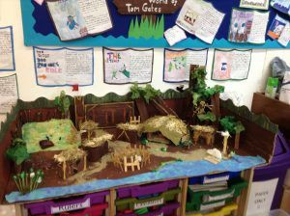  See the attached link to remind you about Anglo Saxon villages. | 3. Topic  (Year 3)  Use the attached framework to write a persuasive text about the most important thing that the Romans brought to London.  (Year 4)  Draw your own version of a map of Africa.  Try to include physical features such as: Sahara desert, Sehel, Savannah, Kalahari desert and tropical rainforest.  Use this link to help you: https://www.mapsof world.com/physical- map/africa.htm | 4. Topic  (Year 3)  Research and write a set of rules for “How to Save the Rainforest”.  You might want to turn these rules into a protest poster.  Example:  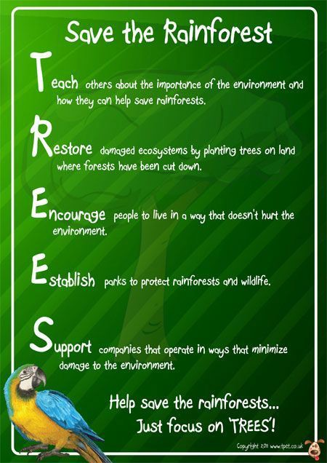  (Year 4)  Make a model of a Viking longship.  You could use paper, cardboard or

any spare materials you have.

Example:

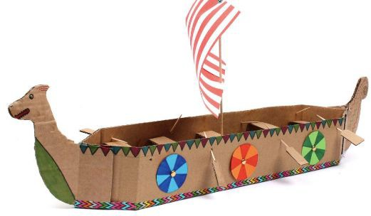

5. English | 6. English  Complete the activities on direct speech. | 7. Reading | 8. Reading
Write your own myth that explains “How The Toucan Got Their Colours”. |  | Complete the attached reading comprehension activities. | Write a letter to the author of your reading book, telling them your thoughts and opinions on the book.
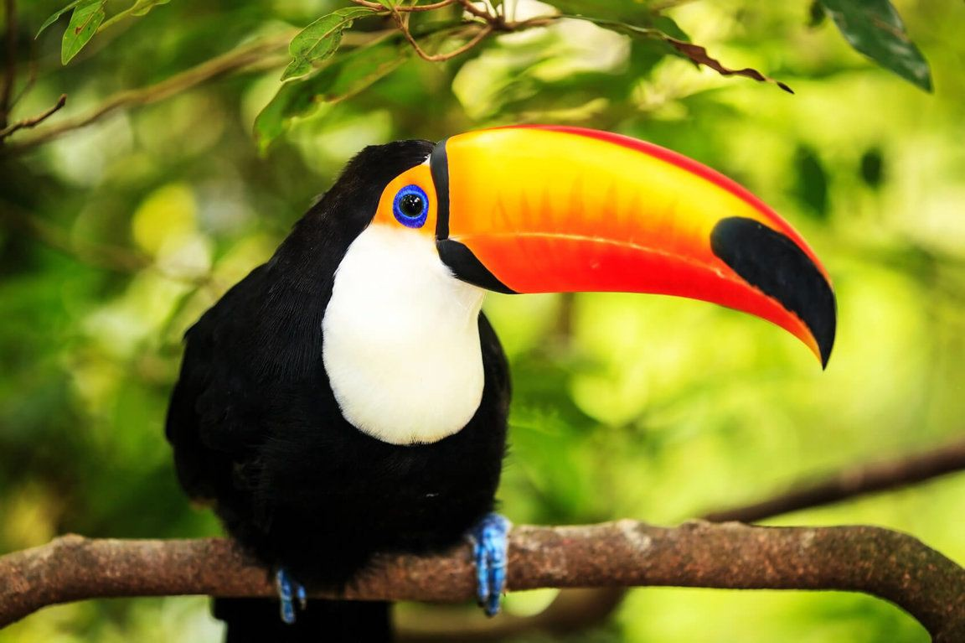

(Year 4)

Write your own myth that explains “How The Whale Got its Blubber”.
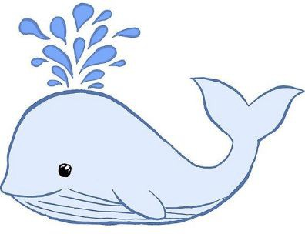

9. Maths  Complete the attached fractions activities. | 10. Maths  (Year 3)  Use this link to practise your times tables:  https://www.topmark s.co.uk/maths-game s/hit-the-button  Also find a times tables test attached for extra practise!  (Year 4)  Log onto Times tables Rockstars and keep at your gigs! You can also practise on hit the button:  https://www.topmark s.co.uk/maths-game s/hit-the-button  Also find a times tables test attached for extra practise! | 11. Maths  (Year 3)  Complete the Colour By Numbers maths sheets.  (Year 4)  Complete the word problems at the back of this home learning pack! | 12. Maths  Make a board game based on word questions that use all 4 operations (addition, subtraction, division and multiplication).  Example:  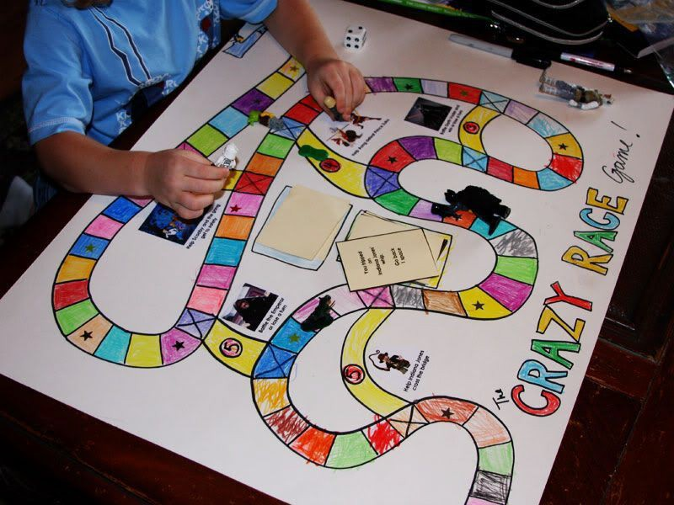
13. Design Technology  Design a healthy recipe and make it for your family.  Record your recipe in your book! | 14. Design  Technology  Using items in your recycling bin make the highest tower possible. Get creative! | 15. Art  Do some plant rubbings. You will have to pick some plants (just a few), place them under a sheet of paper and colour over them with a pencil or crayon. | 16. Art  Answer the attached reflection questions on the artworks provided.

 | Example:  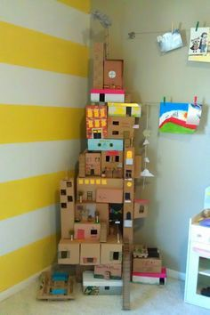 | Example:  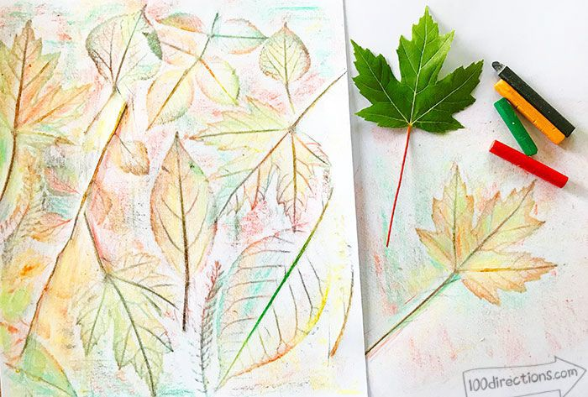
17. Science | 18. Science  Think of something that you want to discover or learn some more about and use Encyclopedia Britannica to research it. It could be do with animals, space, planets, light, sound...anything to do with science!  Link: https://www.britanni ca.com/ | 19. Music  Listen to Vivaldi’s Four Seasons and try and identify which season is being represented at which time.  Write the seasons in the order you think in your book.  Links for listening and learning some more: https://www.youtube  .com/watch?v=g1hE szuZ4lo  https://cityoflondonsi nfonia.wordpress.co m/2015/03/05/vivaldi s-four-seasons-a-kid s-guide/ | 20. Physical  Education
Create a poster  that sorts living and non-living things.  (Year 4) |  |  | Complete one activity from the attached fitness challenge each day.
You could also include some prey, predators and producers!
Example:
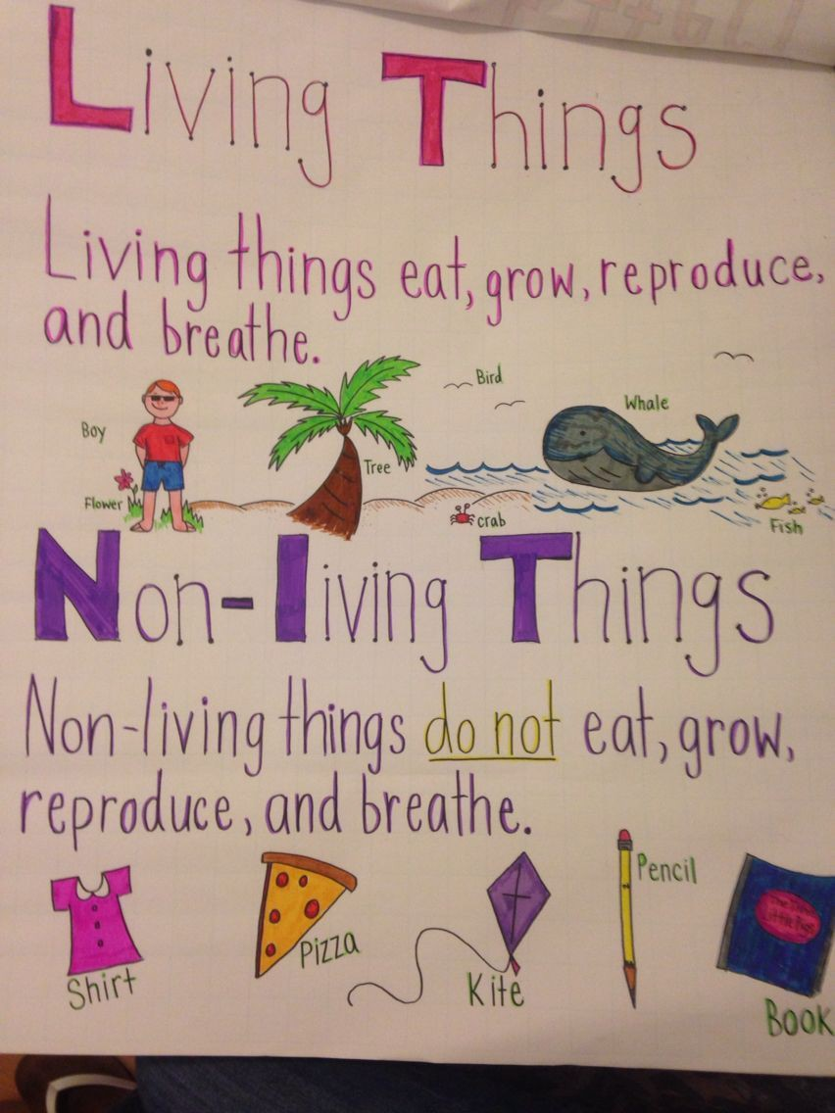

- Remember you should try and do spellings and times tables practise every night as usual.
- You have also been given 2 reading books so you can read every night too as usual.
- Remember to check Sam Learning as well for more online homework.

- Check out these other links for more learning and revision too:

BBC Learning
http://www.bbc.co.uk/learning/coursesearch/
This site is old and no longer updated and yet there's so much still available, from language learning to BBC Bitesize for revision. No TV licence required except for content on BBC iPlayer.

Futurelearn
https://www.futurelearn.com
Free to access 100s of courses, only pay to upgrade if you need a certificate in your name (own account from age 14+ but younger learners can use a parent account).

Seneca
https://www.senecalearning.com
For those revising at GCSE or A level. Tons of free revision content. Paid access to higher level material.

Openlearn
https://www.open.edu/openlearn/
Free taster courses aimed at those considering Open University but everyone can access it. Adult level, but some e.g. nature and environment courses could well be of interest to young people.

Blockly
https://blockly.games
Learn computer programming skills - fun and free.

Scratch https://scratch.mit.edu/explore/projects/games/ Creative computer programming

Ted Ed
https://ed.ted.com
All sorts of engaging educational videos

National Geographic Kids
https://www.natgeokids.com/uk/

Activities and quizzes for younger kids.

Duolingo
https://www.duolingo.com
Learn languages for free. Web or app.

Mystery Science https://mysteryscience.com Free science lessons

The Kids Should See This
https://thekidshouldseethis.com
Wide range of cool educational videos

Crest Awards
https://www.crestawards.org
Science awards you can complete from home.

iDEA Awards
https://idea.org.uk
Digital enterprise award scheme you can complete online.

Paw Print Badges
https://www.pawprintbadges.co.uk
Free challenge packs and other downloads. Many activities can be completed indoors. Badges cost but are optional.

Tinkercad https://www.tinkercad.com All kinds of making.

Prodigy Maths
https://www.prodigygame.com
Is in U.S. grades, but good for UK Primary age.

Cbeebies Radio
https://www.bbc.co.uk/cbeebies/radio

Listening activities for the younger ones.

Nature Detectives
https://naturedetectives.woodlandtrust.org.uk/naturedetect…/
A lot of these can be done in a garden, or if you can get to a remote forest location!

British Council https://www.britishcouncil.org/school-resources/find Resources for English language learning

Oxford Owl for Home https://www.oxfordowl.co.uk/for-home/ Lots of free resources for Primary age

Big History Project
https://www.bighistoryproject.com/home
Aimed at Secondary age. Multi disciplinary activities.

Geography Games
https://world-geography-games.com/world.html
Geography gaming!

Blue Peter Badges https://www.bbc.co.uk/cbbc/joinin/about-blue-peter-badges If you have a stamp and a nearby post box.

The Artful Parent https://www.facebook.com/artfulparent/ Good, free art activities

Red Ted Art
https://www.redtedart.com
Easy arts and crafts for little ones

The Imagination Tree
https://theimaginationtree.com
Creative art and craft activities for the very youngest.

Toy Theater https://toytheater.com/ Educational online games

DK Find Out
https://www.dkfindout.com/uk/…

Activities and quizzes

Twinkl
https://www.twinkl.co.uk
This is more for printouts, and usually at a fee, but they are offering a month of free access to parents in the event of school closures.

Online resources:

- BrainPop

- Curiosity Stream

- Tynker

- Outschool

- Udemy

- iReady

- Beast Academy (Math)

- Khan Academy

- Creative Bug

- Discovery Education

YouTube Channels:

- Crash Course Kids

- Science Channel

- SciShow Kids

- National Geographic Kids

- Free School

- Geography Focus

- TheBrainScoop

- SciShow

- Kids Learning Tube

- Mike Likes Science

- Science Max

- SoulPancake

Lots of board games, library books (and Kindle), tinkering/upcycling with household junk, etc.

Some resources to help with kids at home:

*Scholastic has created a free learn-from-home site with 20+ days of learning and activities.

https://classroommagazines.scholastic.com/support/learnathome.html

*Pretend to travel the world..Go on a virtual tour of these 12 famous museums.

https://allinonehomeschool.com/

Topic

  - Modern European Postcard Template
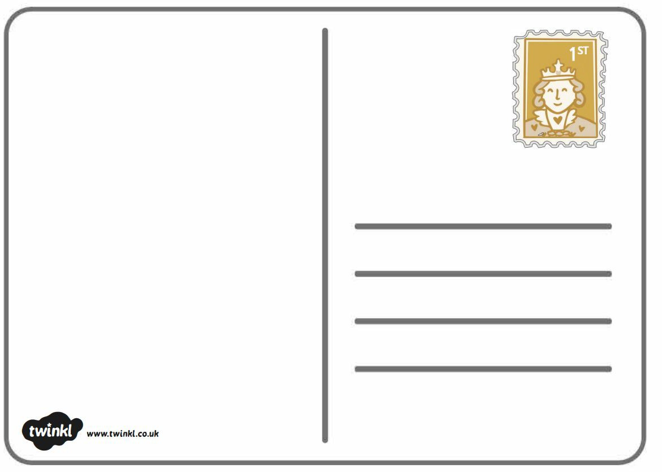

  - Model Anglo Saxon Village
Information on Anglo Saxon villages: https://www.natgeokids.com/uk/discover/history/general-history/anglo-saxons/

Persuasive Writing Template (Year 3)
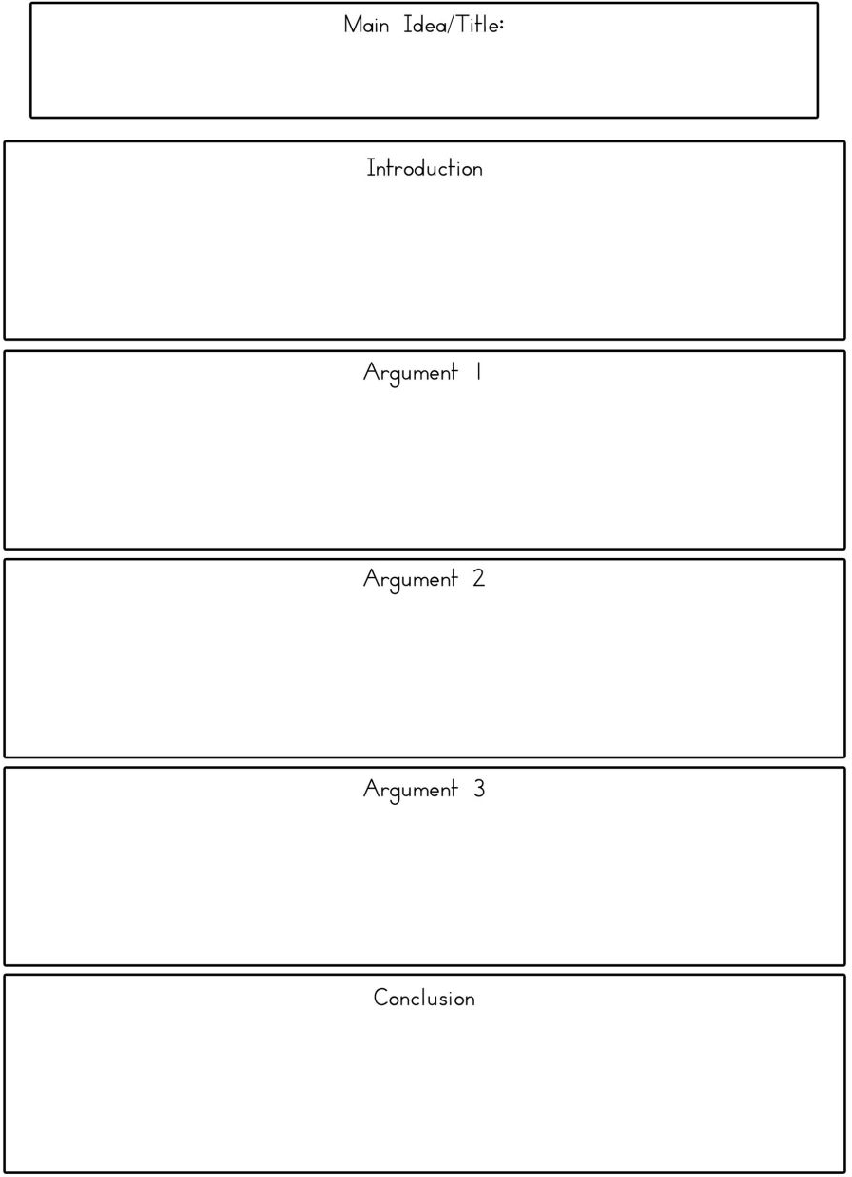

English

6. Direct Speech Activities

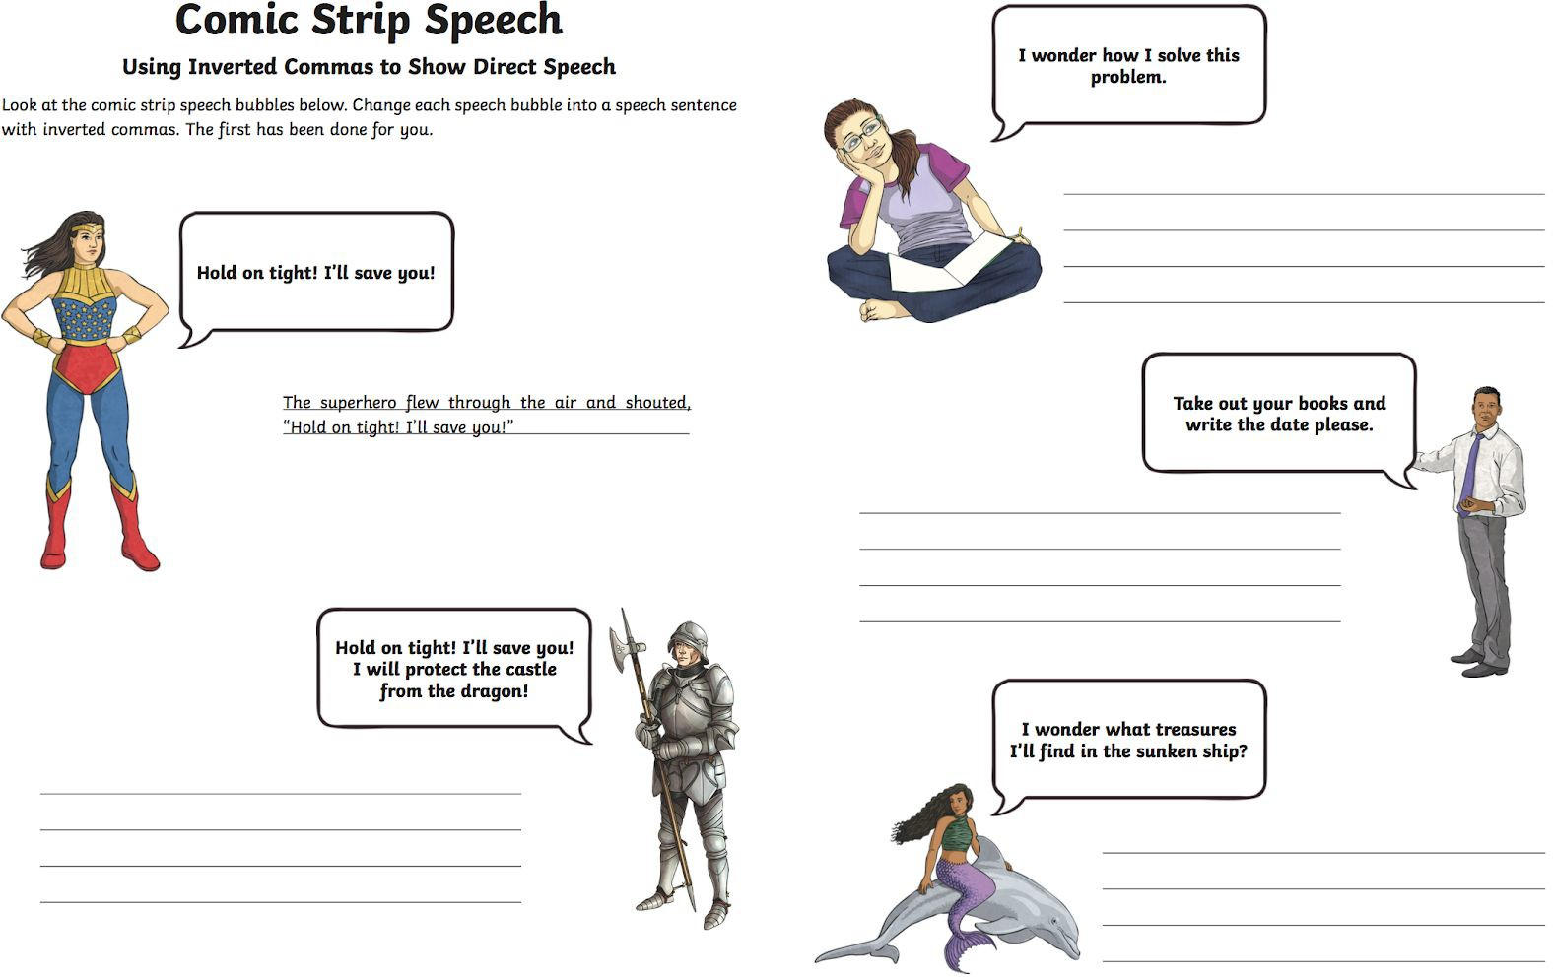

Be the Teacher
Using Inverted Commas for Direct Speech
Mr White is marking the children's work in his class. They have been written using direct speech. Help Mr White by circling the mistakes in each example below and then write it out correctly.
- "We're very proud of him", said Jayden"s parents.

- 'Tm Looking for a dragon, " said Pete. Have you seen him

- "the only tired I was, was tired of giving in," said Rosa.

- "What is it?" asked Hansel. "A house made of sweets," Gretel replied.

- The dentist said "Open wide!"

Spot the Missing Speech Marks

Using Inverted Commas to Show Direct Speech

Loo at the sentences below. Each one is missing inverted commas. Insert inverted commas around the direct speech in each sentence below.

  - What's for dinner dad? Joan asked her dad.

  - The witch looked at her sisters and asked, When will we three meet again?

  - The mouse looked at the fox and quivered, Please don't eat me.

  - I'm stuck! declared Sam as he held up his hand. Can you help me please?
  - Goal! shouted the boy as the ball hit the back of the net.

  - John, can you hold this? asked Alice.

  - Off with her head! shouted the Queen of Hearts.

  - The policeman asked, Can I see your license please?

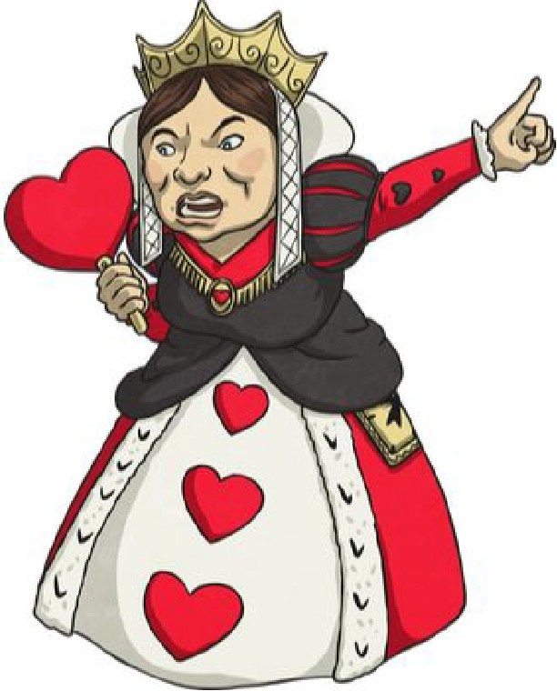

Reading

7. Reading Comprehension Activities

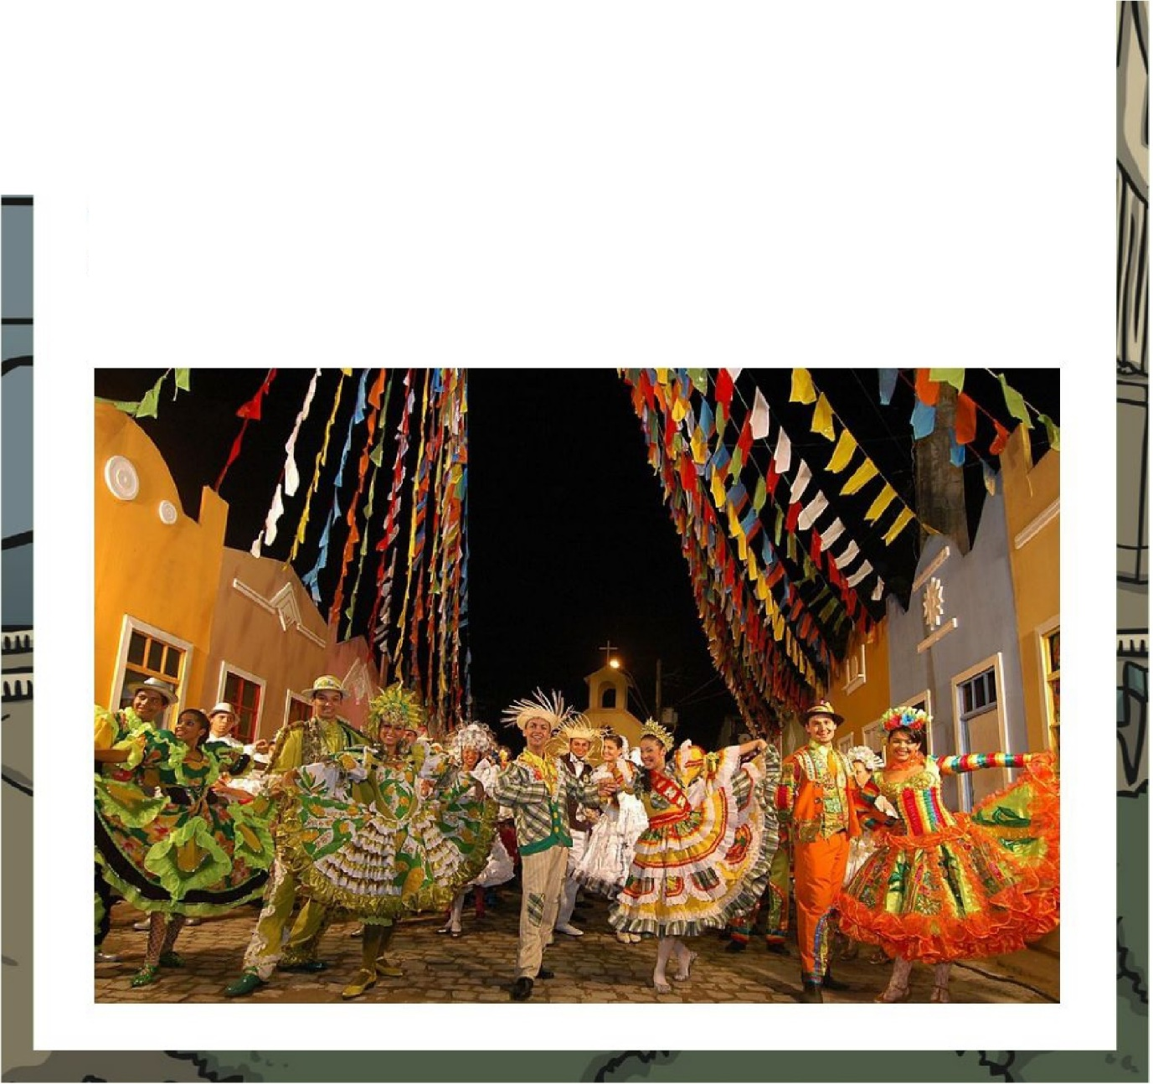
Carnival
There are many festivals and celebrations around the world throughout the year. However, carnival is one of the most famous and flamboyant festivities. Many carnivals take place in the build-up to the religious season of Lent. Lent happens during the six weeks before Easter Sunday, when people prepare for the death and resurrection of Jesus. Therefore, the majority of carnivals take place during February. Lent is a time when, traditionally, people give up something that they will find difficult. This could be a type of food or a bad habit that they want to try to stop.
Carnivals differ from place to place as many areas focus on their own traditions and pastimes and are often heavily influenced by the culture of their country. In most countries, carnival is often characterized by masks, flamboyant costumes, music and colourful floats and parades. Some carnivals have special trinkets or symbols. In New Orleans, they have sweet and very colourful cakes called King Cakes as a symbol of their carnival (Mardi Gras).

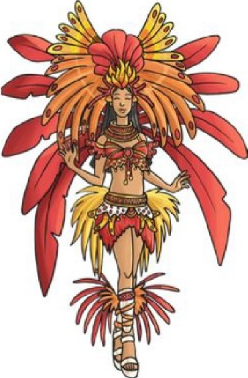
Carnival

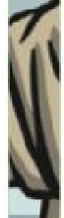
The most famous and largest carnival in the world takes place in Rio de Janeiro, Brazil. Carnival in Brazil is not just a fun celebration, but a chance to experience the diverse culture of the country. Brazil is often referred to as a 'melting-pot' of culture. There are many European, African and American influences in Brazilian society. Carnival epitomises the Brazilian way of life and their way of thinking. There are many parties, which take place throughout the day and during the night, celebrating the songs,
music and dances, typical of Brazilian culture. The most popular form of music and dancing at the Rio carnival is samba, a style unique to Brazil, which is often played on drums with traditional dancing. The 'Sambodromo' is an avenue especially made to host carnival in Rio. Every year, thousands of people go to this area to celebrate carnival, including over 500,000 foreign visitors!
Although carnival is linked to religious faith and traditions, it is a time of fun, excess and flamboyance, enjoyed by millions across the world.

Carnivals in Europe
There are several carnivals in Europe, for example:
Cadiz is where the largest Spanish carnival takes place. It is heavily influenced by local traditions along with current and political events. Lille Rio, there are parades and floats with lots of music.
Nice, in France, is a carnival that is heavily influenced by Catholic traditions. People indulge in lots of rich food in the build up to Lent. One of the most popular street celebrations is the Battle of the Flowers, where there are lots of floats and costumes, brimming with plants and flowers.
Cologne is the principal carnival city in Germany. The carnival season actually begins in November here and culminates the week before (and including) Shrove Tuesday. There are lots of parades and people dress up
- even at work and school. It is one of Germany's most important cultural
events.

Carnival
Questions
- a) When do most carnivals take place?

b) Why do you think this time of year is chosen?

- What does the word flamboyant mean?

- Where do they celebrate Mardi. Gras and what is an important symbol of this carnival?

- Why do you think Brazil is sometimes referred to as a 'melting-pot' of culture?

- Why is carnival so important to Brazil?

- What is different about carnival season in Germany and most other countries?

- Why do you think carnivals are so popular across the world and attract so many visitors?

- Why do you think people give something up for Lent?

- The text says that carnivals are often characterised by masks, flamboyant costumes, music and colourful floats and parades. What does this mean?

- Imagine you have attended a carnival. Describe in three paragraphs, what you have seen, heard and experienced. Use as much detail as possible.

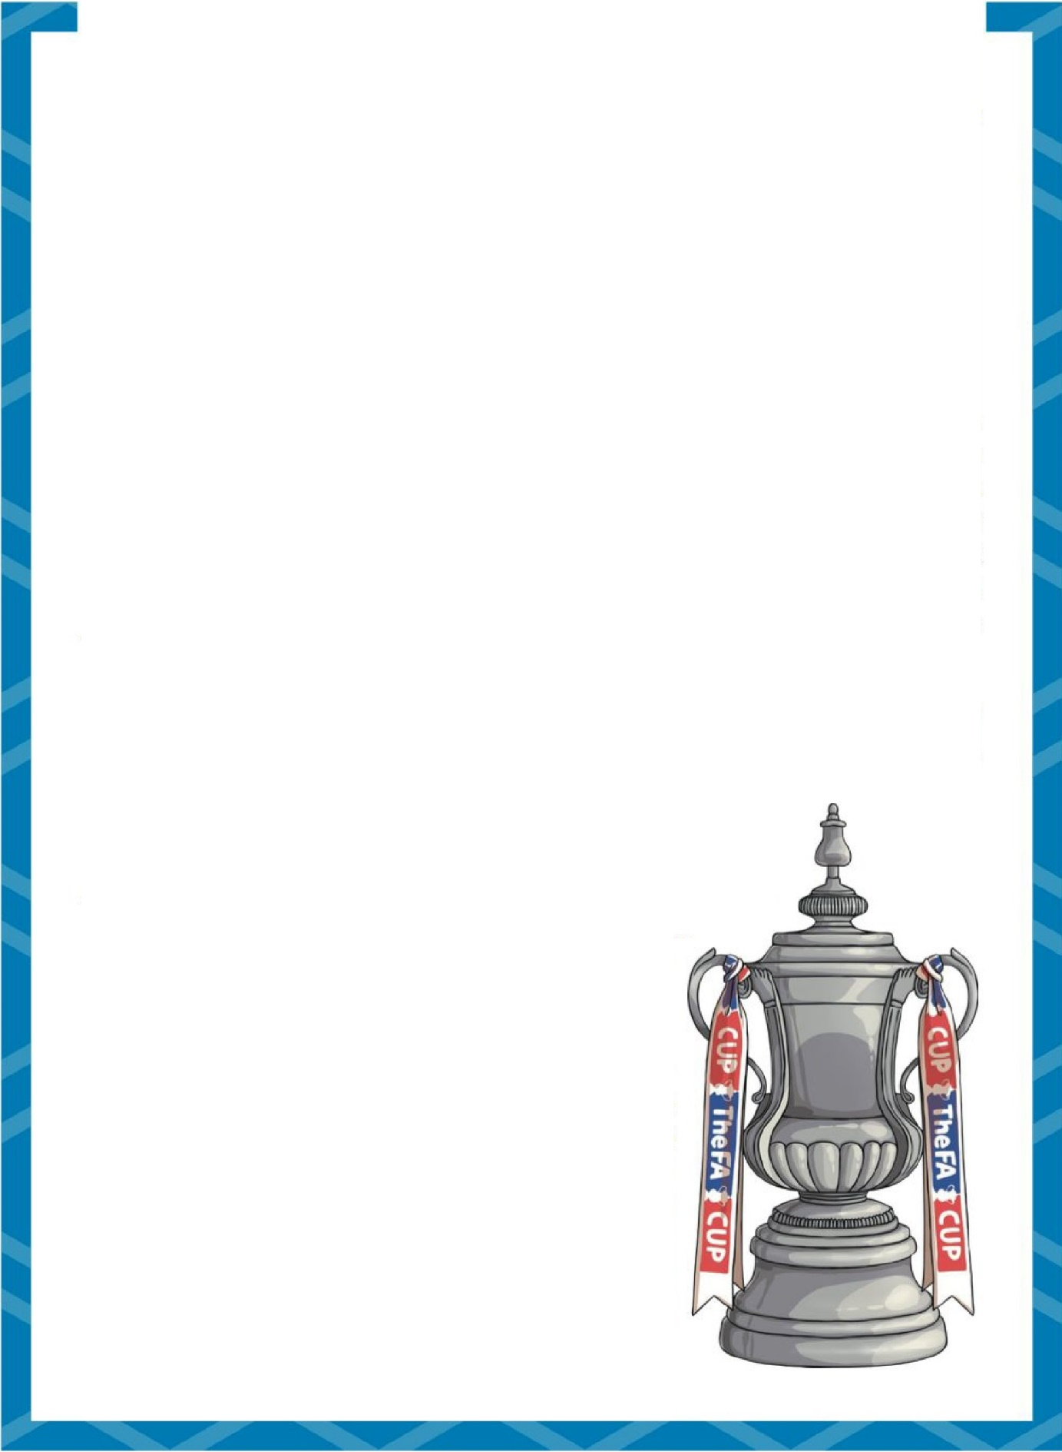
The Football Association Challenge
The Cup Final
Cup Final facts
- The match is widely known as just the Cup Final.
- It is the Last match in the Football Association (FA) Challenge Cup.
- It has about 86 000 spectators and millions of TV viewers.
- The trophy (winner's cup) is only on loan to the winning side.
- It is the oldest cup competition in the world, first played in the
1871 - 72 season.

Who Can Enter?
The Challenge Cup competition is open to any club in the top ten Levels of the English Football League. Once clubs have registered to play, the tournament is organised in.to 12 randomly drawn rounds, followed by the semi-finals and finals. The higher ranked teams join the competition in later rounds when some of the lower ranked teams have been knocked out.

What Do the Winners Receive?
The winners of the fin.al match receive the Football Association. Cup, the FA Cup. It comes in three parts; the base, the cup and a lid. Over the years, there have been two designs of trophy and five cups have been made. The first cup, known as the 'Little tin idol ', was stolen in 1895 and never returned. An
exact replica was made and used until 1910. From 1911, a new design was made. In 1992, another copy was made as the cup was wearing out from being handled, and another replacement was made in 2014. The cup is presented at the end of the match, giving the engraver just five minutes to engrave the winning team on the silver band on the base. The cup has ribbons from both teams decorating it during the final. The loser's ribbon is removed before the presentation. Each club in the final match is given
30 winners or runners-up medals. These are given to players, staff and officials.

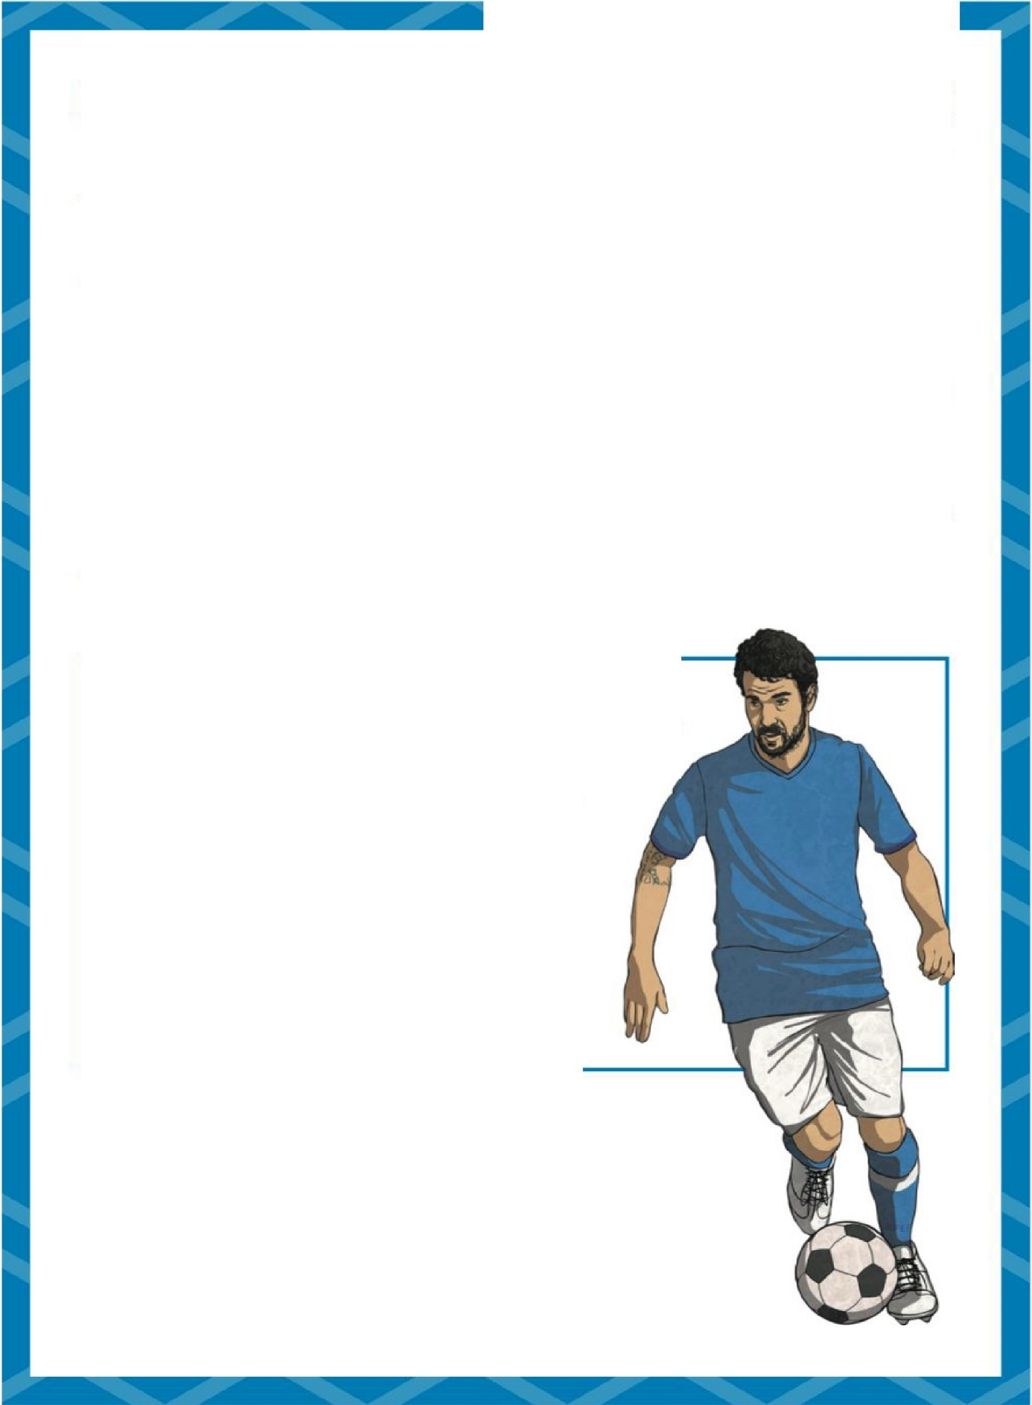
The Football Association Challenge

Most wins:

Fantastic Final Facts
Most appearances without losing:

Arsenal and Manchester United (12)
Most appearances in a final:
Arsenal (20)
Most defeats:
Everton (8)
Biggest winning margin:
- goals (Bury v Derby County, 6-0)
Most goals in a final:
- goals (Blackburn Rovers v Sheffield Wednesday, 6-1 and Blackpool v Bolton Wanderers, 4-3.)
Wanderers (5)
Most appearances without winning:
Leicester City (4)
Youngest FA Cup finalist:
Curtis Weston of Millwall (17 years 119 days.)
Oldest FA Cup finalist:
Billy Hampson of Newcastle United (41 years and 257 days.)

Did You Know?
  - The first winners of the cup in 1872 were Wanderers, who also won it the following year.
  - The Challenge Cup was suspended in 1915 - 1919 because of the First World War.
  - In 1923, the final was played at the newly opened Wembley Stadium.
  - The Challenge Cup was suspended again between 1939 - 1945 because of the Second World War.

The Football Association Challenge: The Cup Final
Questions
- What competition ends in the Cup Final?

- What year was the Cup Final first played?

- Give a reason why the top ranked teams join the competition in round three.

- Find and copy a word that means that the teams were recorded to play in the competition.

- Put the following information in the order it is found in the text. The first one has been done for you.
An exact replica was made.

The losers ribbon is removed before the presentation. The 'little tin idol', was stolen.
The cup was wearing out from being handled.

- Make your choice from the answers below.
- Which team has had the most appearances in. a final? Stafford
Wigan Arsenal Wanderers

- How old was the youngest FA Cup finalist? 41 years 257 days
17 years 119 days

17 years 257 days

41 years 119 days

- Which club has had the most FA Cup wins? Everton
Arsenal

Manchester United and Arsenal Manchester United

- Why was the FA Cup suspended during the First and Second World Wars?

- In what years did Wanderers win the FA Cup?

- How is the information text organised? List two ways.

- Do you think it is better to watch a football match in the stadium, or at home? Explain your opinion.

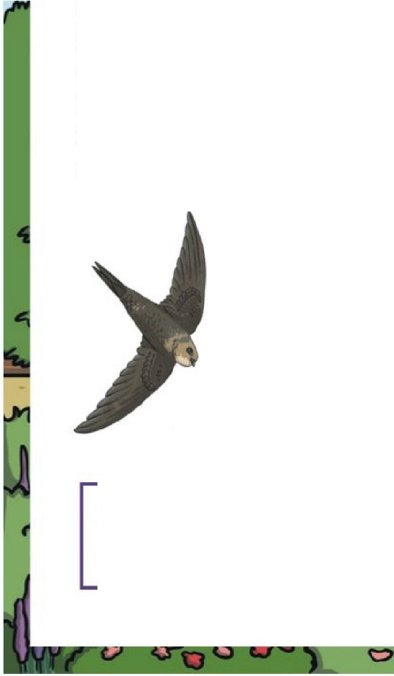
Garden Birds
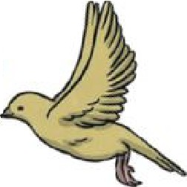
Why do Birds Matter?
  - They help plant life by scattering seeds. This means that seeds get to travel to different places and grow in other places.
  - They control insect growth. Many birds eat insects. Without birds eating them, there would be a dangerously high number of insects.
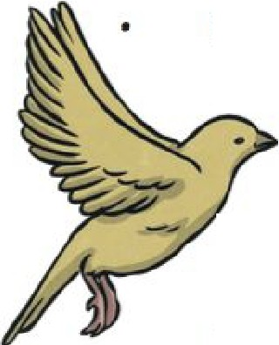
Birds, like magpies and crows, eat dead animals. This gets rid of the rotting animals which could cause diseases.
Numbers of Common Garden Birds

There has been a big drop in the number reason could be that farming has made it
of starlings. The more difficult for

them to find their favourite food - the cranefly larvae.
The number of house sparrows has also dropped. This could be because of cats, or air pollution due to more cars being used. Fortunately, last year, there was an increase in house sparrows reported through an RSPB survey.
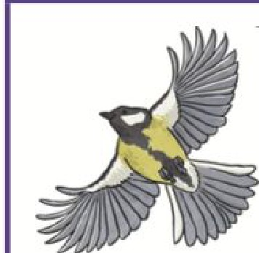
There has also been an increase

In less well-known birds, like fieldfares. One reason for seeing
RSPB
The

Royal Society

more fieldfares in gardens seems to be the cold weather that has made them leave the countryside and look for food in gardens.
Migration
for the Protection of
Birds - a charity that
protects British birds.

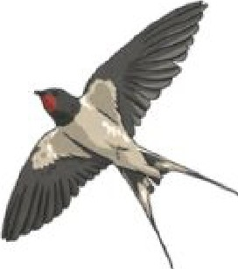
Some birds migrate from the UK during the winter months and return when the weather becomes warmer.
Swifts and swallows migrate to Africa. They can fly 200 miles every day.
    - Many die from starvation, exhaustion and storms.

At the beginning of 2016, there were more sightings of long-tailed tits and goldcrests. A warmer winter meant more of these tiny birds survived.

Gorden Birds

Resident British Birds

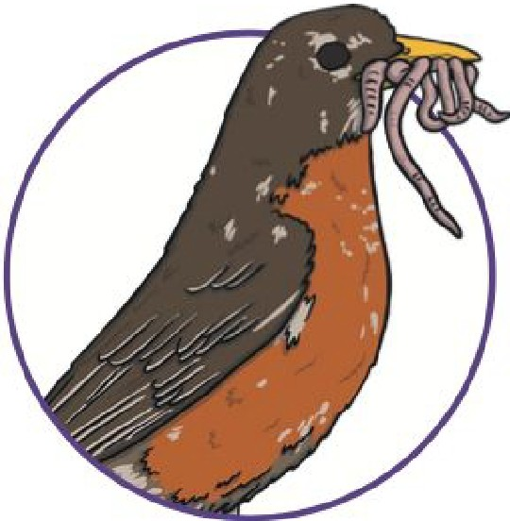
Robins:
- have a bright red breast;
- are very aggressive and will defend their territory;
- sing all year round;
- can be seen in British gardens all year round.

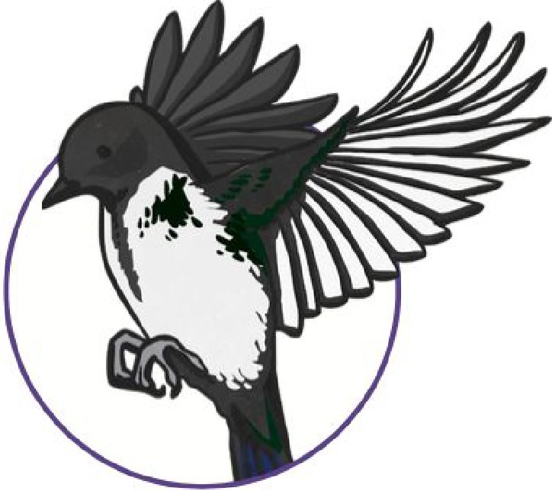
Magpies:
  - have a Loud, chattering cackle;
  - can be easily seen with their white feathers;
  - are important insect controllers;
  - hunt for leftover food and dead animals.

Garden Birds
Questions
- Why is it a good thing that birds help scatter seeds?

- What would happen if birds did not eat insects?

- Name one bird that eats dead animals.

- What is a starling's favourite food?

- Give one reason why there are fewer house sparrows around.

- What do the RSPB do?

- Why are fieldfares having to leave the countryside?

- Why are there more long- tailed tits and goldcrest birds around?

- How far can migrating birds fly ₀₁₁ one day?

- Which word has been used that means robins can get angry with other birds?

- Write two facts about magpies.

  - Letter to Author
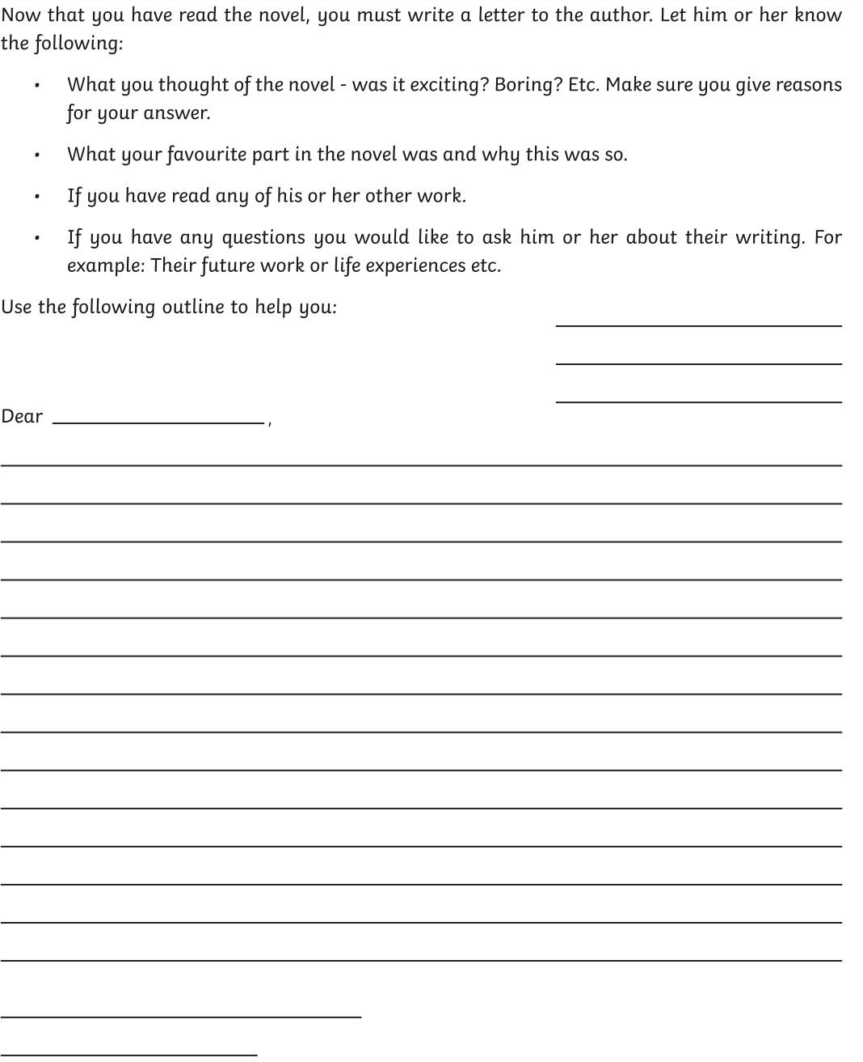

Maths

  - Fractions Activities

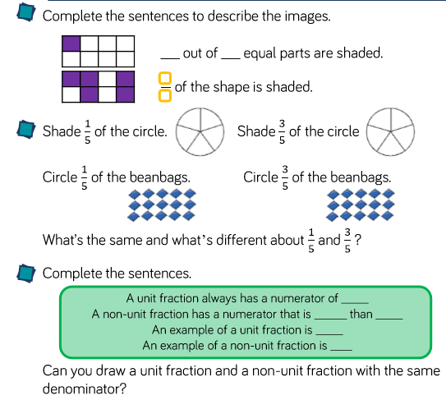

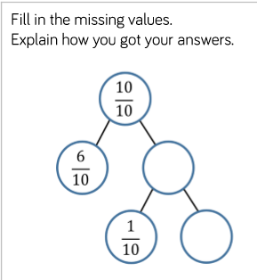

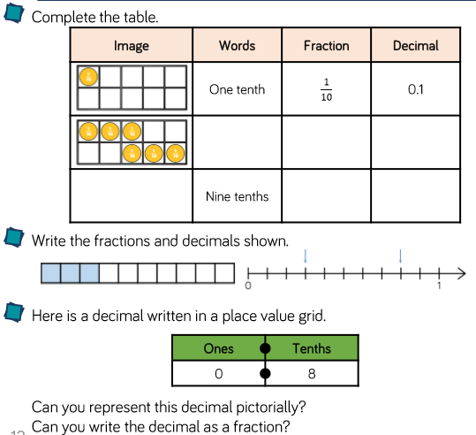

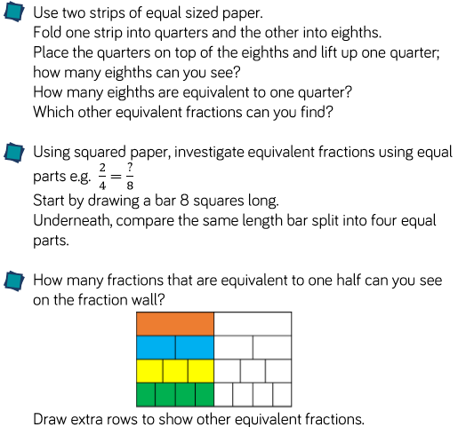

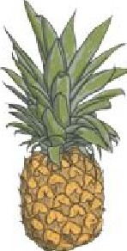
Helpful hint: Drawing diagrams may help you.

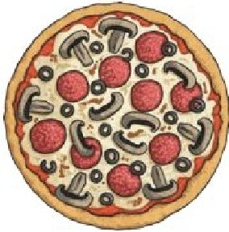
1. Billy ate ¾ of a pizza and Bob ate half of a pizza. Who ate the most? | 2. What comes next? One tenth, two tenths, ...  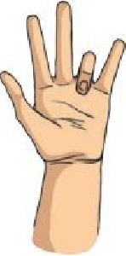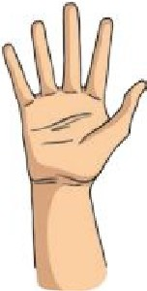

3. A running track is ¼ of a km long. How far would a runner go if he ran round the track 4 times?  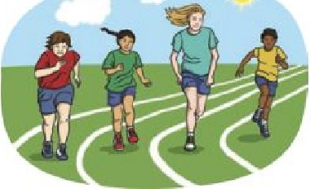 | 4. Hamza chopped up a pineapple and gave ½ to his mum. He also ate half himself. How much was left to give to his dad? | 5. Miriam's dad offered a  choice for her pocket money  - have ¼ of £5 or ½ of £5. Which should she choose?  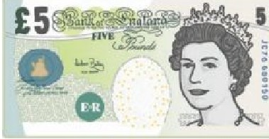

Maths

Times table practice

Art

16. Art Reflection Questions
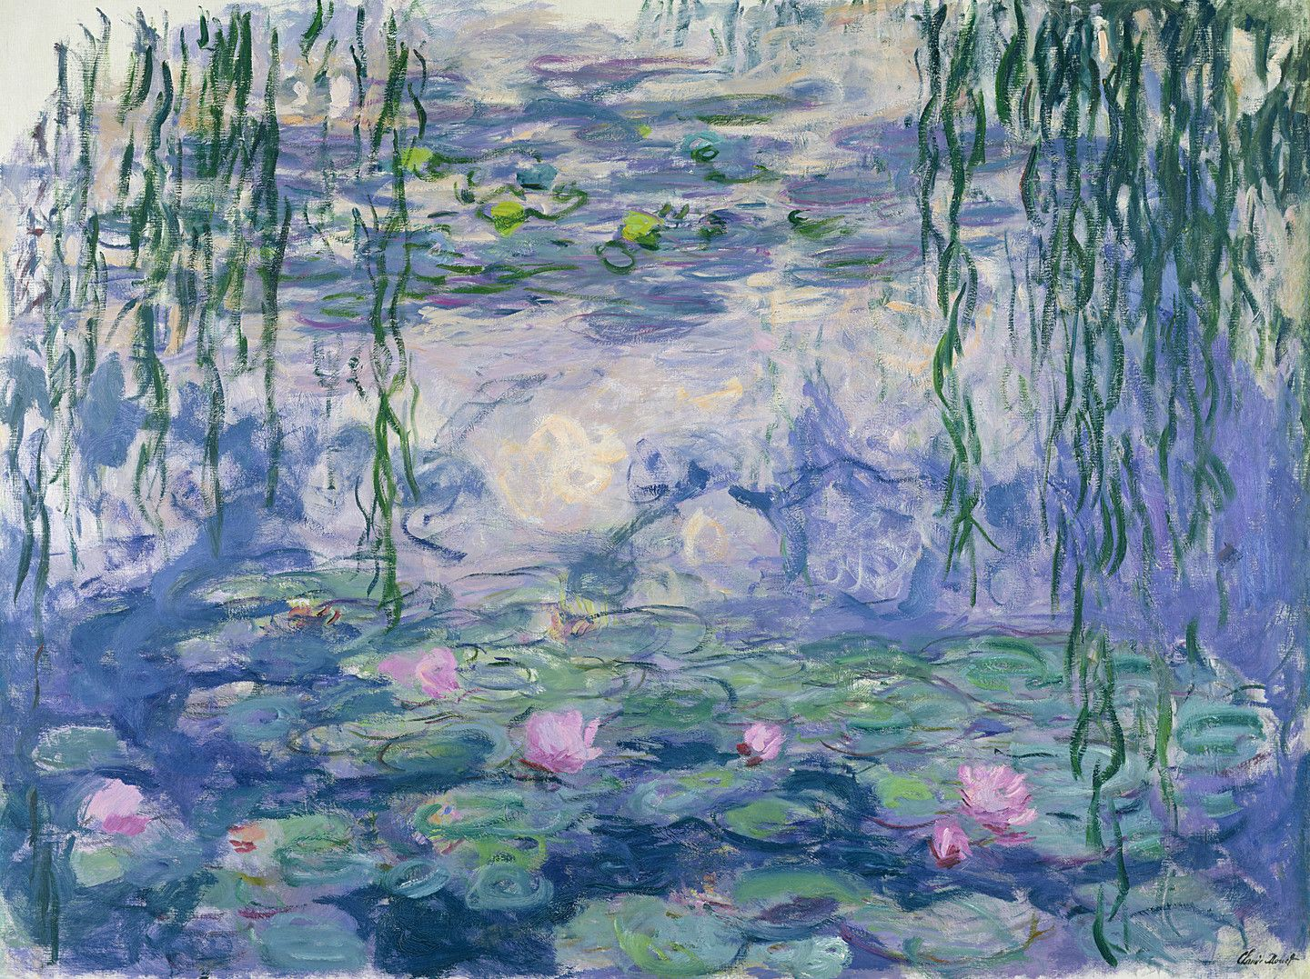
Look at the above artwork by Claude Monet and answer the questions below.
- What is your first reaction to this artwork?
- Describe the lines.
- Describe the colours.
- Do your feelings about this artwork change over time?
- What is mysterious about this artwork?
- How do you think the artist made this artwork?
- Do you like this artwork -justify your answer.

Physical Education

20. Fitness Challenges

