Year 4 Homework- January 2020
- Please complete all tasks during this term
- Write neatly in your homework book and begin each new page with a date and title.
- Remember to practise your spellings every day on Purple Mash
- Sam learning homework will also be set every Monday
- Please hand in your homework book on the last day of the term
Week 1  English: Write a diary entry about a day in your life or a day in the life of another significant person.  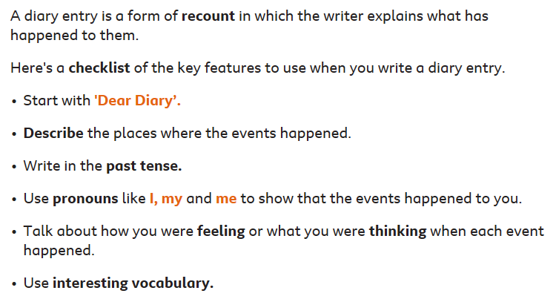  Try to include a rhetorical question!  Topic: Farm to Fork  Draw a picture of your plate and meal. Label the foods and find out where the produce came from.  Can you research one of the foods and create a poster to explain what happened to it before it reached the supermarket? | Week 2  Maths:  Purple Mash- Click on the icons in the order shown below and complete the multiplication and division activities.  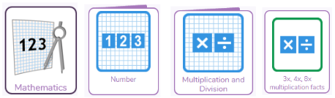  Maths Part 2:  Complete these Multiplying and Dividing activities on BBC Bitesize. https://www.bbc.co.uk/bitesize/topics/z36tyrd  Don’t forget to use tt Rockstars every day!
Week 3  English:  Fronted adverbials - Click on the link to recap Fronted Adverbials.  https://www.bbc.co.uk/bitesize/topics  /zwwp8mn/articles/zp937p3  Part 2  –Re- write the story The Windmill Farmer from the viewpoint of the windmill. What did you see happening on the farm over the seasons? Include fronted adverbials.  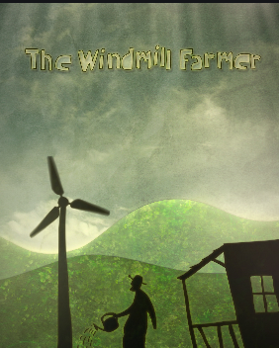  Eg:  Early one morning,  Eventually,  Out of nowhere,  Without a sound,  Maths  Missing number calculations- Remember to try different possibilities and check your answers!  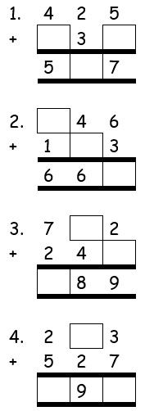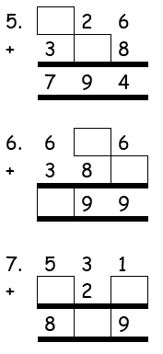 | Week 4  Maths:  Beat the Clock! Do you know all of your times tables up to 12? Click on the link below and work on whichever ones you don’t know:  https://www.topmarks.co.uk/maths-games/hit-the-button  Don’t forget your division facts!  Science- Animals and their Habitats Create a poster to show the living organisms found at the Nature Reserve at Paddington Rec or at your local park. Can you create a branching database or Venn diagram to classify them?  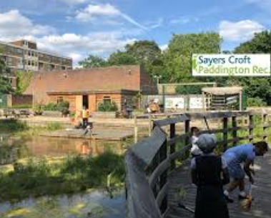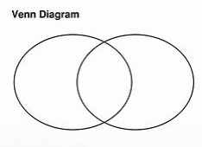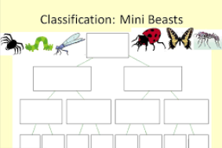
Week 5  Science: Animals and their Habitats  Use the links below to research a habitat of your choice. Create a fact- file about the habitat and it’s animals.  Some questions to help you:  Why is the habitat the best for the animals in it?  How does the habitat change over time?  Which other plants and animals are suited to this habitat and why? https://kids.nationalgeographic.com  /explore/nature/habitats/ocean/  Maths-  https://www.bbc.co.uk/bitesize/clips/z3hxpv4  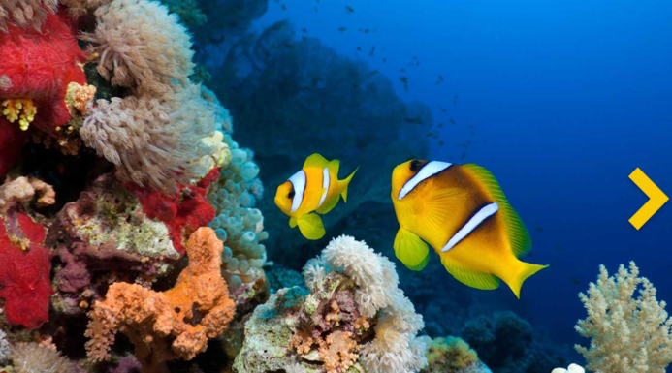 | Week 6  Topic:  Design your own Fair Trade poster and include your own logo. Your poster should include an explanation of what Fair Trade is and why it is important. Your poster will be entered into our Year 4 competition!  Maths:- Multiplication workbook- Your teacher will give this to you this week.
Spellings, times tables (tt rockstars) and reading must be practised every night!

