English | Think about a familiar story that you have read and enjoyed and re-tell the story. To make it interesting change the ending of the story.  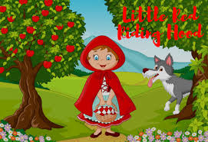  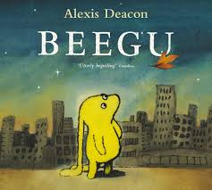 | Practise using pre-cursive handwriting and write sentences  a b c d e f g h i  j k l m n o p q  r s t u v w x y z | Find out interesting facts about  Jacqueline Wilson and the names of the books she wrote. Read one with an adult.  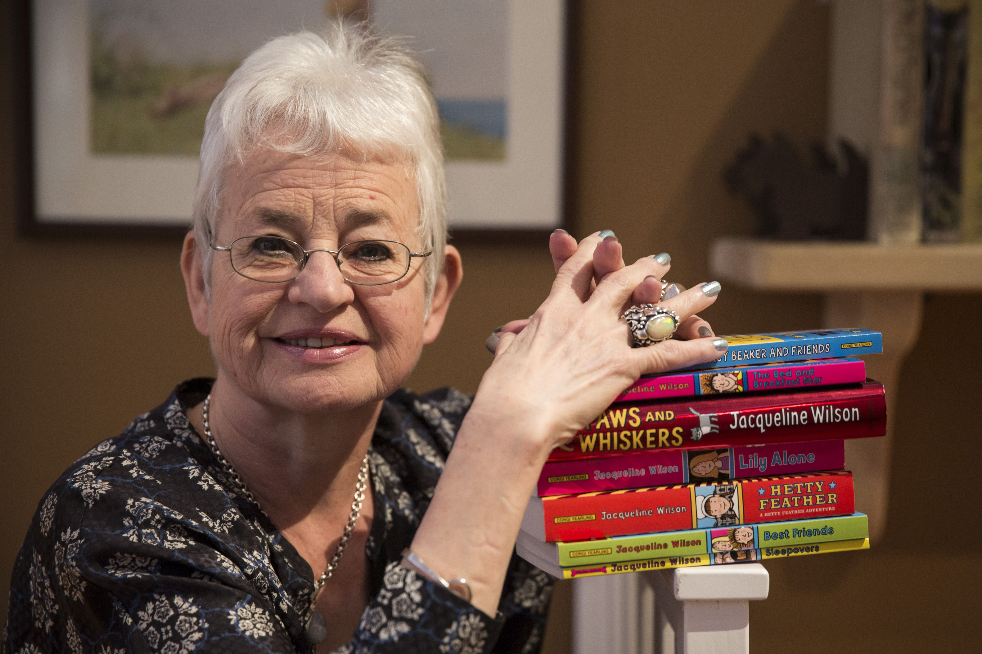
Maths | Practise your 2,5,10 timetables  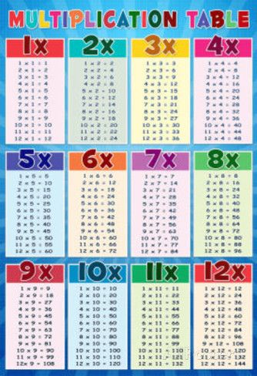  Challenge- learn your 4 times table | We have been learning about sharing equally in groups. Have a go at making equal amounts with different groups and writing statements to match  There are ____ equal groups with _____ in each.  ___ + ___ = 6 | Write your numbers in words from one to hundred.  Example:  21 = twenty one  22 = twenty two
Science | Draw a diagram of a plant and label it’s parts  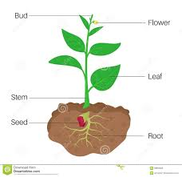 | Plant your own seed and keep a diary of how it grows.  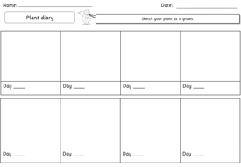  Draw each stage of the plant and write a short description | Grow some cress seeds and see what happens when planted in different conditions  1st cress- water and sunlight  2nd cress seeds- water but no sunlight  3rd cress seeds – no water and no sunlight  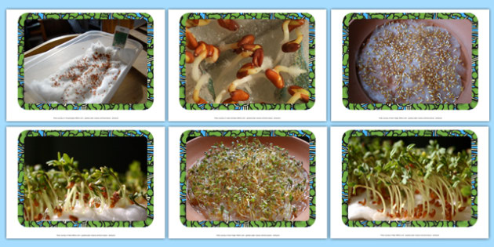  Record your results after 7 days  How to grow cress seeds  https://www.youtube.com/watch?v=q1eIjzGqIaI
Topic | Take a walk around your local area. Make a list of the things you see on your walk  e.g. post office, bus stops, train station, school  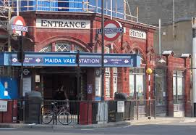  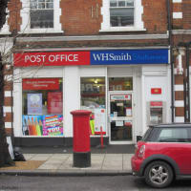  Post office Train station | Create symbols that you can use on a map to show the different features in your local area.  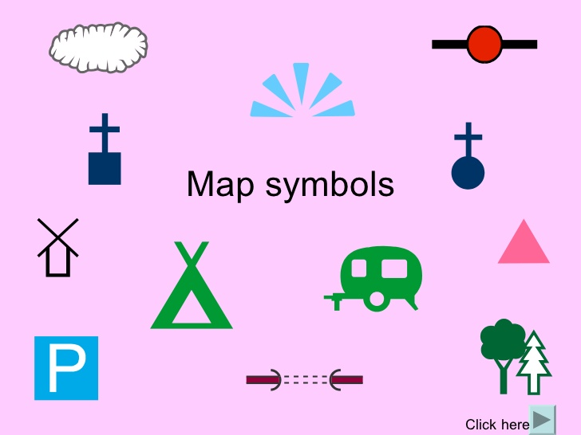 | Draw a map of your local area.  Include:  - A key  - Symbols  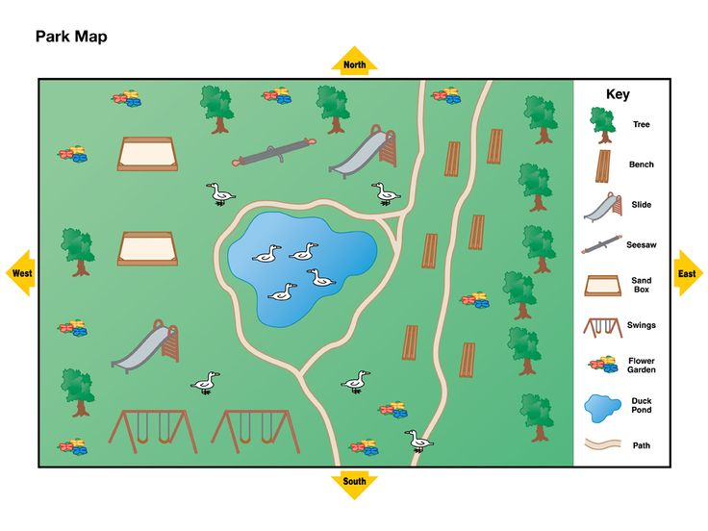
Creative | Make a bus, train or bike out of junk model materials.  Can you make it move? Remember to include the axle and axle holder.  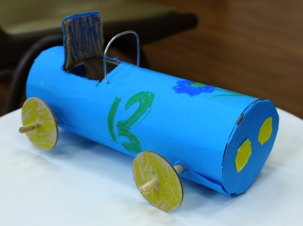 | Draw/ paint a season tree.  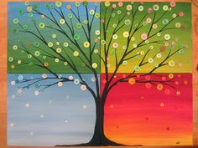 | Design and make your own wind mill using different materials. Be creative  