English | 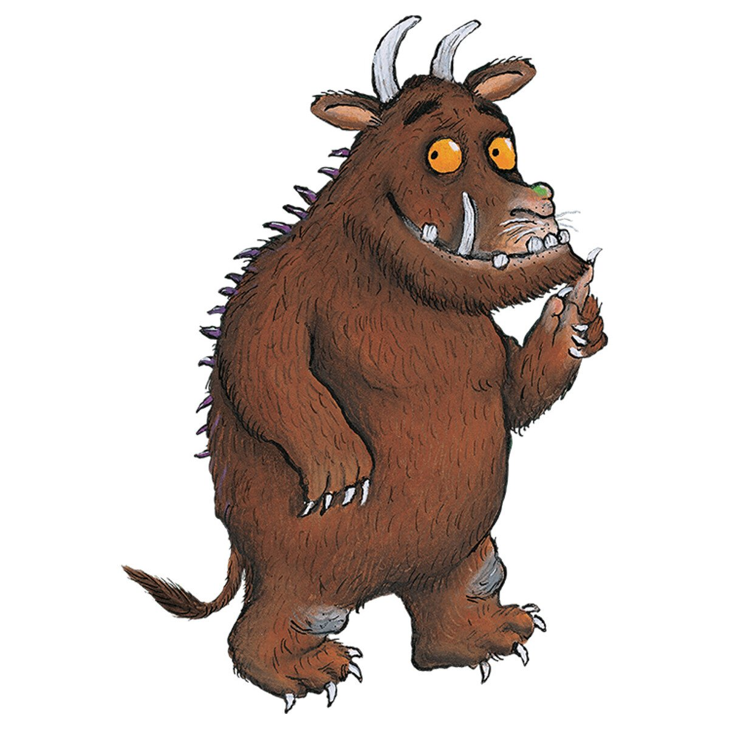  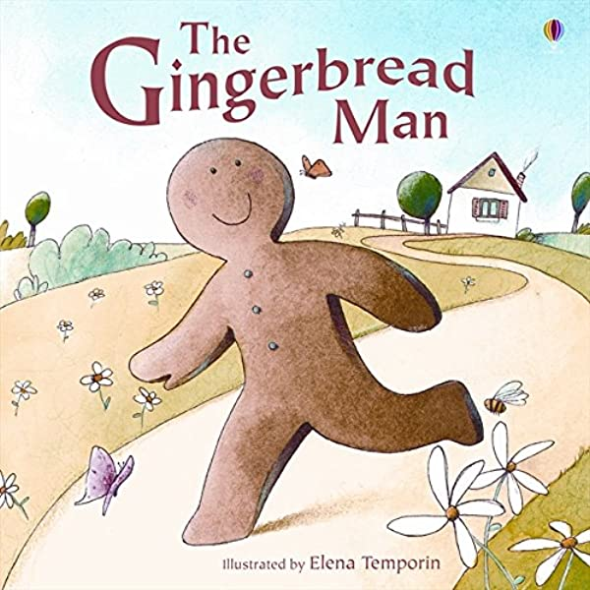  Choose a familiar story/ fairy tale and try to write a recount of it. | Practise using pre-cursive handwriting  a b c d e f g h i  j k l m n o p q  r s t u v w x y z | Listen to a rhyming story, e.g. Julia Donaldson books such as ‘Room on the Broom’. Can you identify the rhyming words?  Can you choose your own word and create a list of words that rhyme with it?
Maths | Ensure you are familiar with basic 3D shapes. Talk about their properties i.e. faces, edges and vertices. | 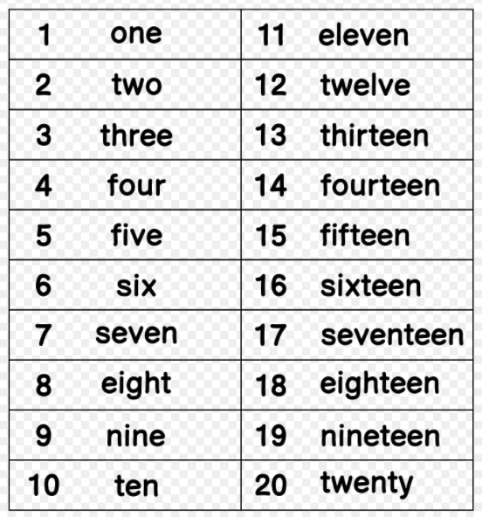  Continue to practice writing numerals in words from 1 – 20 | How many number sentences can you make using numbers 1 – 20?  Use addition and subtraction  Example:  3 + 7 = 10  5 + 11 = 16  18 – 2 = 16  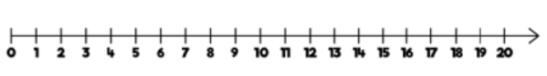  Use a number line to help you
Science | Go for a walk outside and take photos of nature around you. What season is it? What signs in nature tell you what season it is? Can you see any differences between now and Summer?  Challenge!  Can you investigate daylight hours? How many hours of light are there each day? Does it change?
Topic | Take a walk around your local area. Make a list of the things you see on your walk  e.g. post office, bus stops, train station, school  Post office Train station | Create symbols that you can use on a map to show the different features in your local area.  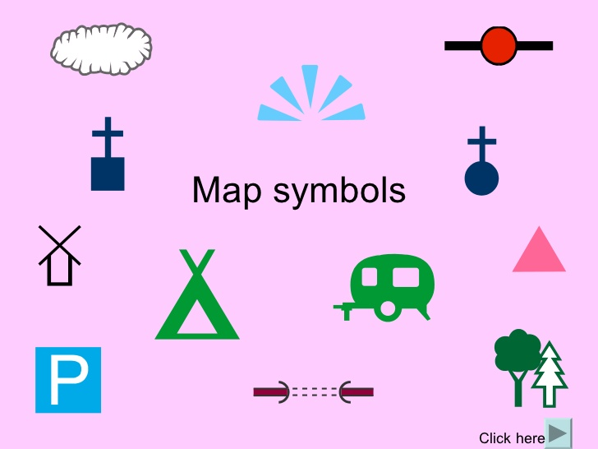 | Draw a map of your local area.  Include:  - A key  - Symbols  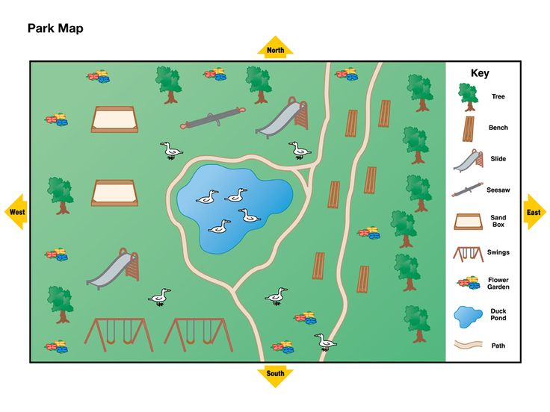
Creative | Can you make a vehicle at home using card and straws. Remember that you need to have axles and axle holders to enable the vehicle to move.  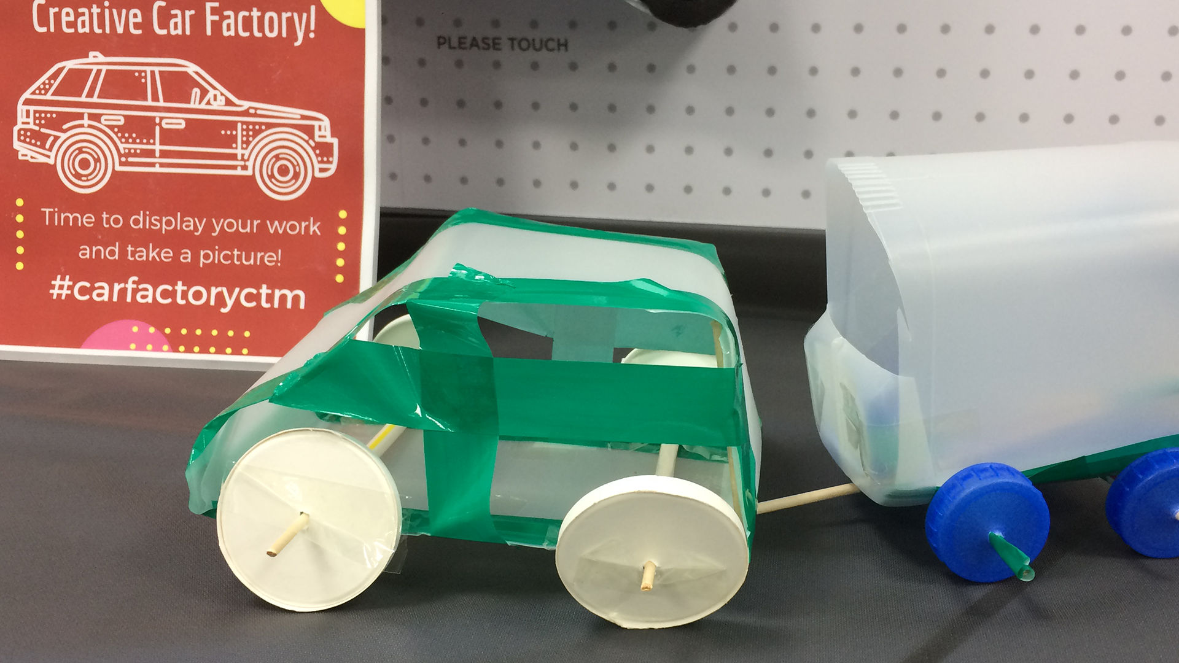  . | Draw/paint your own ‘season’ tree (see below). | Create your own windmill using different materials. Be creative!  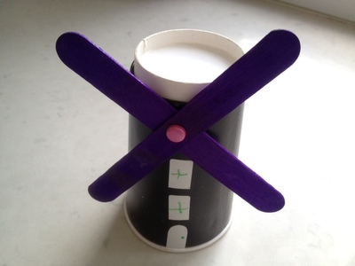
Phonics | Please continue to:  Practise recognising Phase 2-5 sounds and tricky words  Read your reading book to practise your Phonics  Read and write words/sentences with your Phase 5 sounds in  Go on ‘Phonics Play’ and explore the games available  Visit ‘Teach Your Monster To Read’

