English | Practice your spellings every day.  (see page 2 -  high frequency words)  Read a book every day.  Write a few sentences about your favourite book this week. | Retell the story of  The Gruffalo.  Who is your favourite character? Why?  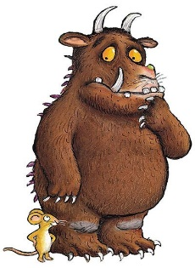  Draw a picture  of your favourite character. |  | Practice writing the days of the week.  Write the days on a list starting from Monday.  Which day were you born? |  | Can you use the  past tense?  Make a list of 20 verbs.  e.g. brush – brushed  Are there any exceptions?  Highlight them.  Write 10 sentences using some of the listed verbs.
Maths | Name the 3D shapes. | What are the missing numbers on this  number line? |  |  |  | Draw 6 tanks and draw 5 fish on each tank.  Complete the calculation.  How many fish altogether?
 |  | Can you make your own number line from 0 to 50? Count in steps of 5.
Science | Explain what the following words mean:  Herbivore  Carnivore  Omnivore | Draw and label  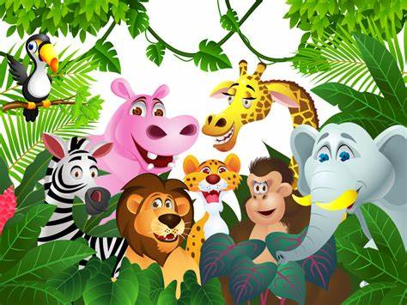  5 herbivores  5 carnivores  and  5 omnivores |  |  | Make fake snow using  baking soda and shaving foam.  Can you create your own snowman?  Take pictures to share with the class.
Creative | 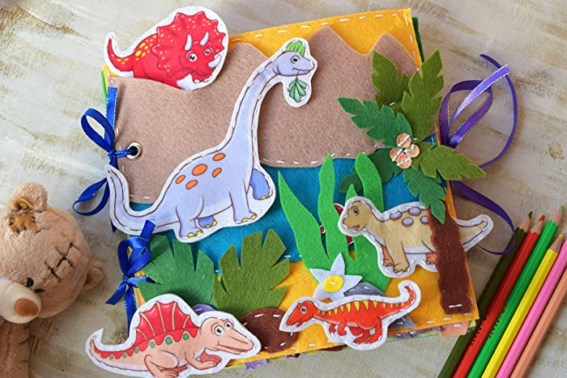  Find information, draw pictures about different dinosaurs, and create your own dinosaur book. | Design your own cake.  Make a list of the ingredients you will need using bullet points. Do not forget to use a heading. |  | Make your own cake.  Take pictures to share with the class. |  | Project:  Animals and Habitats  (see page 3 and 4)  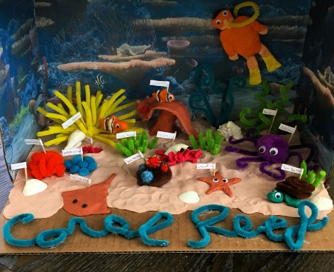
Geography | Design and colour your own poster  about London  - Why is it a special place to live?  - What are the main landmarks?  - What can you do there? |  | We already know that the UK has four countries:  England, Scotland, Wales and Northern Ireland.  Write a few notes about each country. |  |  | Create your own paper mache globe.  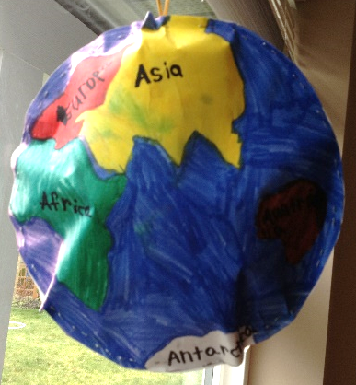  Can you label the continents?

Week 1 Week 2

MY ‘Animal Habitat’ PROJECT (what to do…)
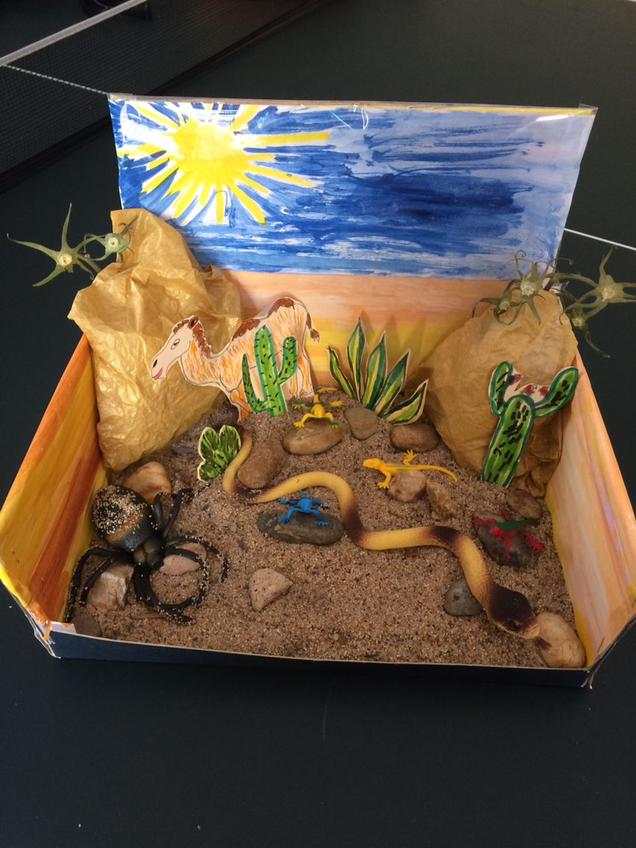
Dear 1Y and 1A,

Your task is to research and collect information about ‘ANIMALS and their HABITATS’, so you have something to share with the rest of the class.

You can either:

- Make a model of your favourite habitat:

- ocean, desert, forest, rainforest, woodland, grassland, tropical rainforest, arctic, tundra etc.

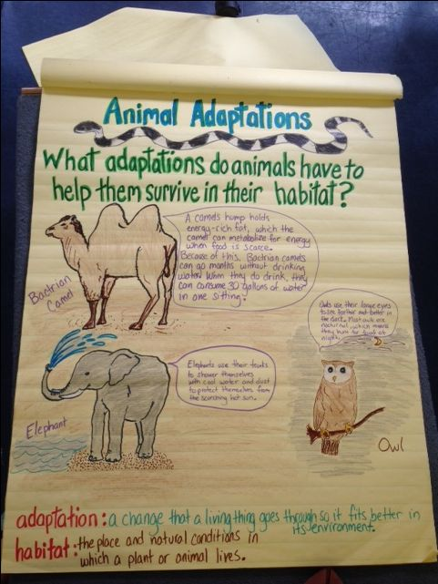
- Produce a piece of writing to go with your model to explain what it is and what animals and plants live there.

- Create a ‘booklet’ or ‘file’ with a clear, colourful front cover page.
Include:

- Introduction
- Topic headings
- Drawings/photos
- Use your neatest handwriting and make sure
it is in your own words.

- Create a large poster (e.g. A3). Make it as eye-catching and informative as possible. Similarly, use topic headings and pictures to do so.

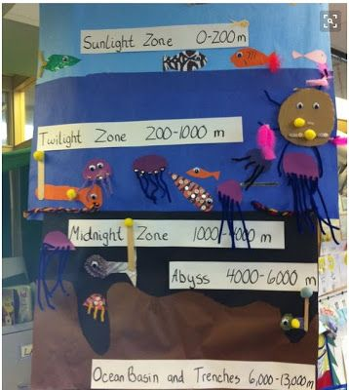

A prize will be awarded for the best 3 projects. The focus for these projects is to develop your research skills. I will be particularly interested in the model projects and the writing that is in your own words!

Have fun researching all about Animals and their Habitats!

Mr Yianni

